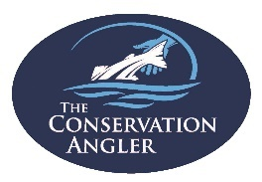Comments on Columbia River Steelhead Return in 2023

The 2023 return was much better than the original predicted forecast from the state fishery managers. The pre-season forecast for wild summer steelhead passing Bonneville Dam from April 1 thru October 31 was predicted to be fewer than 21,000 wild fish. The actual return of wild or unclipped steelhead was 40,654 steelhead past Bonneville Dam – twice as many as predicted! If you are going to be wrong, let’s be wrong in the right direction!
While that was only a pre-season forecast, the inaccuracy should set off some alarm bells for the fish agencies.
The lowest preseason forecast – ever – lower than the previous actual lowest return in 2021, seemed dire. Let’s look back before we look forward for silver linings.
In 2021, the pre-season forecast was about 100,000 total steelhead. The actual run totaled about 70,000 hatchery and wild fish. The final number of wild steelhead returning in 2021 was less than 25,000 fish.
The number of wild steelhead predicted to pass over Bonneville Dam in 2023 was less than 21,000 fish - for the entire Columbia and Snake River Basin – so the actual return of over 40,000 steelhead is truly a blessing.
Considering the steelhead status, and the fishing regulations we have seen enacted over the past few years of low wild steelhead numbers, Oregon has taken a proactive stance:
First, the Department and then the Commission created the Thermal Angling Sanctuaries at the Deschutes in 2018, and then permanent rules at three cold water refugia by 2020.
Second, the Commission held a special meeting in August 2021 to address the unexpected decline in returning steelhead and some rivers were closed to steelhead angling.
Third, in 2022, ODFW developed an outreach program with anglers and developed a series of Fishery Frameworks to provide as much certainty for anglers – and protection for wild steelhead as possible.
For these actions, we are grateful and TCA believes that Oregon stands tall compared to our neighboring states to the North and East.
Nevertheless, the overall status of wild steelhead still demands an open and careful review of the regulatory scheme in place since 2021.
When TCA examines the impact of the extraordinary regulations put in place in 2021, we see by the reduction in angler effort and steelhead encounters that these regulations made a difference in wild fish reaching their spawning grounds in greater numbers and in better shape.
TCA is concerned that the fishery framework in place – reliant on wild steelhead return estimations from the 2022-23 spawning season (still underway) – will result in open seasons at the beginning – at a time when wild fish make up the majority of the early steelhead return.
Something just does not seem right about a plan to allow fisheries that will impact the wild run more than the hatchery component. We urge great caution and we urge the Commission to engage with the public on this issue now and not in June or July.

Report on Wild Summer Steelhead returning to the Columbia River above Bonneville Dam
Total Summer Steelhead Passage: April 1 thru November 30
- 114,310 combined hatchery and wild steelhead (H + W) passed Bonneville Dam
- 40,654 total unclipped steelhead passed Bonneville Dam (see Note)
Note: 6 to 11 percent of the unclipped steelhead passing Bonneville are unclipped hatchery-origin steelhead

- The current 10-year average steelhead passage (2013-2022) is 160,529 (combined hatchery & wild steelhead).
- The current 10-year average for wild or unclipped steelhead passage is 58,540 summer steelhead.

Comparing passage with the Current Ten-year Average (CTYA) (2013-2022):
- The 2023 return of combined wild and hatchery steelhead is 71% of the CTYA.
- The current 2021 forecasted return of wild summer steelhead is 70% of the CTYA.
- Unclipped hatchery steelhead outnumbered unclipped/wild steelhead by some 33,000 fish.
- Keep in mind that 6 to 11% of adipose-intact fish are actually hatchery-origin).

To avoid succumbing to the declining baseline syndrome, we must compare current run-size with a longer data period or with a more productive period to identify the overall loss of wild steelhead productivity and abundance:
The “best” ten-year average for total steelhead since 1984 occurred between 2001-2010 (410,370 steelhead (H+W).
The “best” ten-year average for wild steelhead since 1984 also occurred from 2001-2010 (118,257 wild steelhead).
Thus, the current 2023 return of total hatchery and wild steelhead is 28% of the best 10-year average (BTYA).
The current 2023 return of wild/unclipped steelhead is 34% of the BTYA.

Columbia River DART comparing 2023 Wild/Unclipped Steelhead returns with Best 10-year Average.
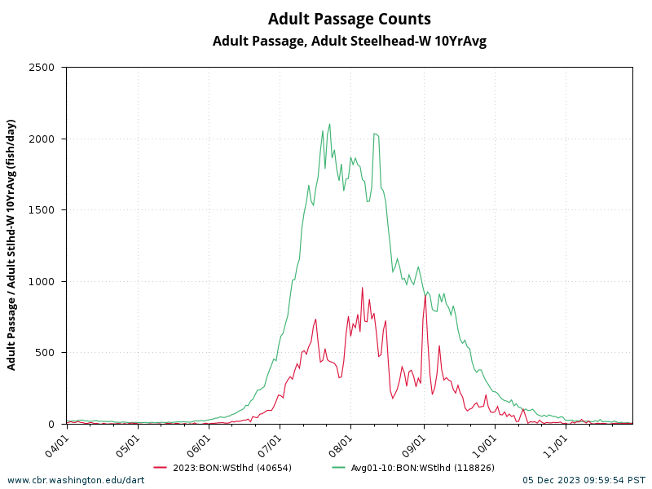
Columbia Basin wild Steelhead face many challenges, but the current status of wild summer steelhead reflects an ongoing failure to set and meet spawning escapement criteria for Idaho, Oregon, and Washington wild steelhead rivers. Wild Steelhead productivity and abundance declines are affected by this failure in several ways.
Mainstem Fisheries:
- Wild steelhead face non-tribal and Tribal commercial fisheries in the Columbia, sport fisheries in the Columbia and Snake Mainstem as well as Columbia and Snake tributaries where sport and tribal fishing is authorized.

- Even when limited, sport fisheries authorizing hatchery steelhead retention will also create lethal encounter impacts for wild steelhead that are not accurately observed or monitored.

- Tribal fisheries, by Treaty, may harvest, and by state action, sell wild steelhead caught in platform, set net and drift gill net fisheries throughout the Columbia and Snake River and in some tributaries. Monitoring and reporting are inadequate to accurately assess overall impact during authorized fisheries that enable managers to take precautionary in-season conservation action when steelhead runs are low.

- Summer Steelhead, particularly B-run steelhead, are harvested incidentally in non-tribal commercial fisheries and harvested directly in Tribal fisheries that are primarily aiming to catch summer and fall chinook and coho. Wild B-run steelhead are repeatedly caught and released in sport fisheries in the mainstem and in tributaries.

- Wild B-run steelhead migratory mortality is too high evidenced by calculating the “conversion rate” for wild B-run steelhead that documents the loss of wild B-run fish between Bonneville and Lower Granite Dam due to harvest, fish passage mortality, predation, poaching and natural causes. In the last decade, the average percentage of wild B-run steelhead passing Bonneville but not reaching Idaho is 44.65%.
Hatchery steelhead releases in tributaries throughout the three-state region compete with wild steelhead for rearing space and for forage. Mass hatchery releases also attract avian and fish predators throughout the migratory pathway and pose inordinate predation impacts for wild steelhead co-migrating with hatchery fish.

Sport Fish Issues:
- Anglers may use bait, barbed hooks, and treble hooks when steelhead fishing in rivers where wild fish must be released. Catch and release mortality rates for bait are higher than for artificial lures and flies (Think John Day).
- Anglers fishing in boats may continue to fish even when they have taken their limit, increasing the number of wild steelhead that are caught, adding to more lethal and sub-lethal encounters and loss of energetics.
- Sport fishing on some tributary streams is allowed on other fish species but results in targeting steelhead.
- Wild steelhead are encountered more frequently in Columbia and Snake River fisheries even though hatchery fish regularly outnumber wild fish in mainstem and tributary fisheries by two or three to one.
- Because most summer steelhead will not spawn until late winter through spring, their migratory behavior is less predictable and more likely to result in multiple angling encounters during their spawning migration.
- Fishing for steelhead is permitted in some rivers throughout staging and spawning activity in February to June.

Migratory Conditions:
- Steelhead rely on cold water refugia (CWR) during their migration, and once the water temperatures reach 68.5F, their residency and use of the CWR increases from days and weeks to weeks and months.
- Wild steelhead relying on CWR are susceptible to angling pressures while in residency – this negates the conservation benefit of the CWR to migrating ESA-listed wild steelhead.
- Instream flows and augmentation flows are insufficient and are not prioritized to provide enough cool water when environmental conditions place migrating wild steelhead and salmon at high risk.
- Thermal Angling Sanctuaries in the Columbia River are essential conservation tools for wild summer steelhead.

Compiled by David Moskowitz * The Conservation Angler * david@theconservationangler.org * 971-235-8953
The Conservation Angler is a wild fish and wild rivers advocacy organization. www.theconservationangler.org

Numeric Data is from the UW Columbia River DART website: http://www.cbr.washington.edu/dart/query/adult_graph_text

